Shuttle vector
- Prokaryotic vectors cannot exist & work in eukaryotic cells because the system of two groups of organisms varies. Prokaryotes lack introns; while eukaryotes consist of introns. Therefore, vectors with two origin of replication were constructed which may exist in both eukaryotes and prokaryotes.
- A shuttle vector is a vector usually a plasmid constructed so that it can propagated itwo different host spesies. Therefore DNA inserted into a shuttle vector can be tested or manipulated in two different cell types. Since these vectors can be grown in one host and then moved into another without any extra manipulation, they are called shuttle vectors.
- It has two origins of replication, each of which is specific to a host. Since shuttle vectors replicate in two different hosts, they are often known as bifunctional vectors.
- One of the most common types of shuttle vectors is the yeast shuttle vector. Amost all commonly used Saccharomyces cerevisiae vectors are shuttle vectors.
- Yeast shuttle vectors are components that allow for replication and selection in both E. coli and yeast cells. The E. coli. component of a yeast shuttle vector includes an origin of replication and a selectable marker, e.g., antibiotic resistance. The yeast component of a yeast shuttle vector includes autonomously reploicating sequence (ARS), a yeast centromere (CEN) and a yeast selectable marker (e.g., URA3, a gene that encodes an enzyme for uracil synthesis)

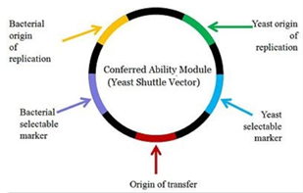

One of the reasons behind the use of shuttle vector is that it might be difficult to recover the recombinant vector from the transformed yeast colony in which YEp might have integrated into the yeast chromosome; hence the purification of the plasmid vector might be impossible. Therefore, the standard procedure in yeast is to perform the initial cloning experiment with E. coli, and to select recombinants in this organism. Recombinant plasmids can then be purified, characterized, and the correct molecule introduced into yeast.
